**Relief Point**

***Work-flow to Use Relief Point***

Use **Load Template** to set up the preference for various conditions



Repeat **Load Template** for additional instances of any template



***Preference Overview***

This preference sets stops eligible for use as driver changeover points. In addition, any stops within a specified radius of a relief point may also be used as a relief point.

***Templates Available from Optibus***

Three pairs of templates are supplied. The difference between the two items in each pair is that one is a constraint and the second is preference with a penalty.

*Table 1-1: Templates Summary*

|  |  |  |  |
| --- | --- | --- | --- |
| **Template** | **Type** | **Purpose** | **Reference** |
| Relief Point - by route | Preference | Set a relief point stop group for a specific route. A distance threshold is also defined. | **Relief Point Prefer- ence - by route** |
| Constraint | **Relief Point Con- straint - by route** |
| Relief Point - by route group | Preference | Set a relief point stop group for a specific group of routes.  A distance threshold is also defined. | **Relief Point Prefer- ence - by route group** |
| Constraint | **Relief Point Con- straint - by route group** |
| Relief Point | Preference | Set a relief point stop group. A distance threshold is also defined. | **Relief Point Prefer- ence** |
| Constraint | **Relief Point Con- straint** |

***Relief Point Preference - by route***

**Purpose:**

Set a relief point stop group for a specific route. A distance threshold is also defined.**Prerequisites:**

You should have already defined your stop groups. See Miscellaneous Preferences, **Stop**

**Groups**.

**Opening Dialog:**

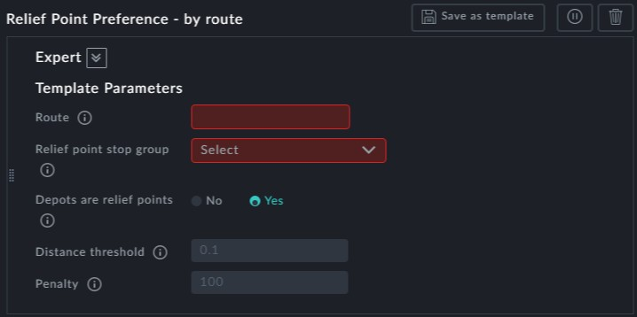

**Points to note:**

**Route**: Route sign is a mandatory field



**Relief point stop group**: This is a mandatory field. You may choose from a dropdown list of your stop groups:

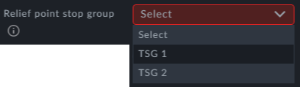

**Depots are relief points**: Set this to Yes if you want Depots to also be relief points.



**Distance threshold**: Any stops within the specified radius of a relief point may also be used as a relief point. Specify the radius here.



**Penalty**: Preferring the relief stops carries a penalty



Use **Load Template** to create additional instances



***Relief Point Constraint - by route***

**Purpose:**

This instance is the same as **Relief Point Preference - by route** but without a penalty field - it is a constraint.

***Relief Point Preference - by route group***

**Purpose:**

Set a relief point stop group for a specific group of routes.

A distance threshold is also defined.

**Prerequisites:**

You should have already defined your stop groups. See Miscellaneous Preferences,



**Stop Groups**.

You should have already defined your route groups. See Miscellaneous Preferences,



**Route Groups**.

**Opening Dialog:**

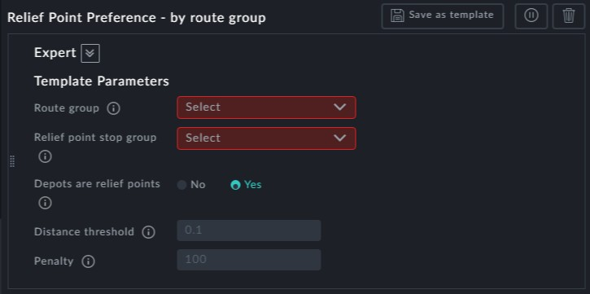

**Points to note:**

**Route** group : Route sign is a mandatory field. You may choose from a dropdown list of your route groups:

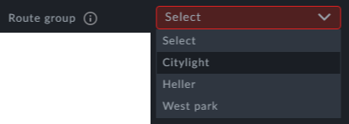

**Relief point stop group**: This is a mandatory field. You may choose from a dropdown list of your stop groups:



**Depots are relief points**: Set this to Yes if you want Depots to also be relief points.



**Distance threshold**: Any stops within the specified radius of a relief point may also be used as a relief point. Specify the radius here.



**Penalty**: Preferring the relief stops carries a penalty



Use **Load Template** to create additional instances ***Relief Point Constraint - by route group* Purpose:**



This instance is the same as **Relief Point Preference - by route group** but without a

penalty field - it is a constraint.

***Relief Point Preference***

**Purpose:**

Set a relief point stop group. A distance threshold is also defined.

**Prerequisites:**

You should have already defined your stop groups. See Miscellaneous Preferences, **Stop**

**Groups**.

**Opening Dialog:**

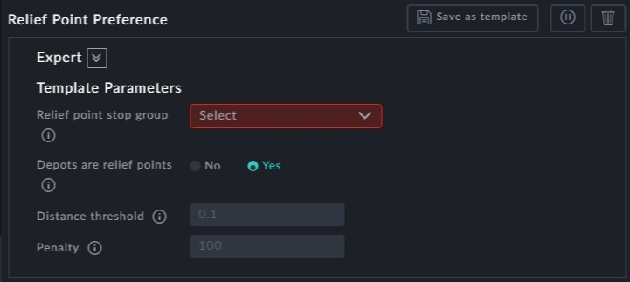

**Points to note:**

**Relief point stop group**: This is a mandatory field. You may choose from a dropdown list of your stop groups:



**Depots are relief points**: Set this to Yes if you want Depots to also be relief points.



**Distance threshold**: Any stops within the specified radius of a relief point may also be used as a relief point. Specify the radius here.



**Penalty**: Preferring the relief stops carries a penalty



Use **Load Template** to create additional instances



***Relief Point Constraint***

**Purpose:**

This instance is the same as **Relief Point Preference** but without a penalty field - it is a constraint.